RTB

How much is being finished and failed

* There are a couple that we can send metrics from sherlock io

Elasticsearch

* Update by query

<https://www.elastic.co/guide/en/elasticsearch/painless/master/painless-update-context.html>

* Copy field value to another field

POST /indexName/_update_by_query

{

"query": {

"constant_score" : {

"filter" : {

"exists" : { "field" : "copyFrom" }

}

}

},

"script" : {

"source": "ctx._source.copyTo = ctx._source.copyFrom;"

}

}

POST /change_info_metadata_2022/_update_by_query

{

"query": {

"constant_score" : {

"filter" : {

"exists" : { "field" : "info.placementIds" }

}

}

},

"script" : {

"source": "ctx._source.placementIds = ctx._source.info.placementIds;"

}

}

POST change_info_metadata_2022/_update_by_query

{

"script": {

"source": "ctx._source.experiment = null",

"lang": "painless"

},

"query": {

"bool": {

"must": [{

"exists": {

"field": "experiment"

}

},

{"match": {

"type": "EP"

}}]}

}

}

Errors

## **query_shard_exception at** shard **0**index **shepherd_metadata_change_info_2022**node **gl7IfI-KTYi-bWXF2k4h0w**

**Type**

query_shard_exception

**Reason**

failed to create query: For input string: "2021-06-07T19:00:23.100Z"

**Index uuid**

4sHWKsXQQc2Na4nd08FB8g

**Index**

shepherd_metadata_change_info_2022

**Caused by type**

number_format_exception

**Caused by reason**

For input string: "2021-06-07T19:00:23.100Z"

IntelliJ

* Configure new Maven project
* Configuration 1
  + Name: adsmetadatasvc
  + ​​run: clean spring-boot:run -Dspring.profiles.active=default,dev -f pom.xml
  + Working directory: adsmetadatasvc
* Configuration 2
  + Name: adsinfra-dimension
  + ​​run: clean spring-boot:run -Dspring.batch.job.names=dimensionAppender -Dspring.profiles.active=default,dev -f pom.xml
  + Working directory: adssrejob
* Configuration 3
  + Name: adssrejob
  + ​​run: clean spring-boot:run -Dspring.profiles.active=default,dev -f pom.xml
  + Working directory: adssrejob
* Configuration 4
  + Name: adssrejob-epchange
  + ​​run: clean spring-boot:run -Dspring.profiles.active=default,dev -Dspring.batch.job.names=epChangeScrubber -f pom.xml
  + Working directory: adssrejob

mvn clean install -DskipTests=true

Talend API Tester

HOMESPLICE

Homesplice calls Cassini

Home splice is serving the merch application from the view item service side

They go to NORI and recommend

When we show item they go to impression

BES

* Ebay homegrown messaging system stored in Oracle

There are a few pools that consume the message

* Seller
* Attribution

5% sales cannot be attributed because of delay

Xid batch is for the 2% missed

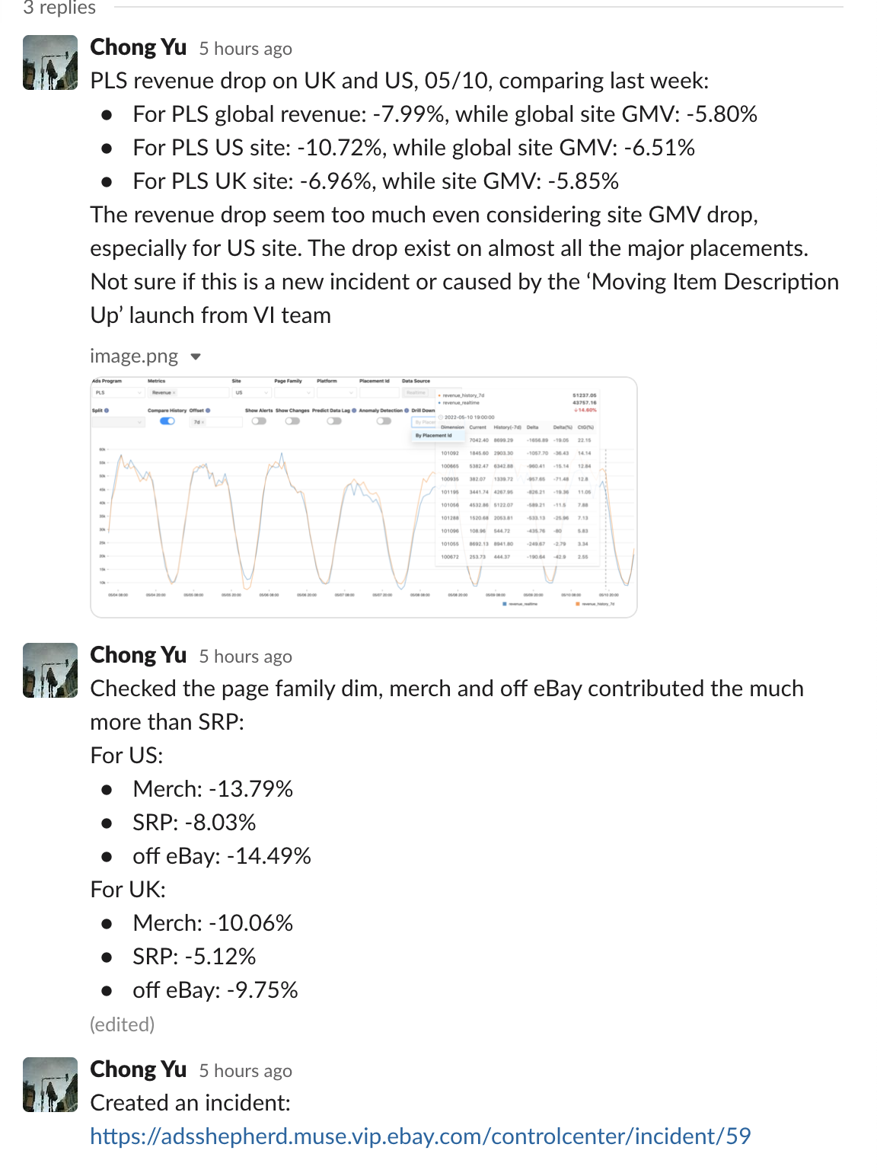

Need to stick to the implementing CR.

Another issue, did not follow the implemented CR.

Approver responsibility

Executor responsibility

SFA

Conversations:

# EP to POOL INFO



[**Clark Jason Bautista Ngo**](https://app.slack.com/team/U02AJT5UGQ4) [1 day ago](https://ebay-eng.slack.com/archives/CPH9BKS0G/p1654200216951269)

Hi EP Team, do EPs correlate to impacted pools?

Like is there any info on what pools/code EP touches?



[**ExperimentationBot**](https://app.slack.com/team/U02U0S58CAE)**APP** [1 day ago](https://ebay-eng.slack.com/archives/CPH9BKS0G/p1654200218831069?thread_ts=1654200216.951269&cid=CPH9BKS0G)

Thanks for contacting Experimentation team! We've found some related posts on Stack Overflow, please check them first:

1. [How to setup EP from scratch - any guide / wiki / epguide](https://stackoverflow.com/c/ebay/questions/6431)

2. [EP Permission](https://stackoverflow.com/c/ebay/questions/6421)

3. [How to get opt-in URL](https://stackoverflow.com/c/ebay/questions/6433)

4. [How do I turn OFF Experimentation?](https://stackoverflow.com/c/ebay/questions/2527)

5. [Add new (supportive) metrics into the existing running report of the EP](https://stackoverflow.com/c/ebay/questions/6691)

If you want to get more details, please contact @ask-kalin.



[**Edward Jan**](https://app.slack.com/team/W3XUNL0G1) [7 hours ago](https://ebay-eng.slack.com/archives/CPH9BKS0G/p1654278243693219?thread_ts=1654200216.951269&cid=CPH9BKS0G)

[@cjasonbautista](https://ebay-eng.slack.com/team/U02AJT5UGQ4) Let me clarify your question. I assume that you want to know if EP reporting correlate to the application or service pool (e.g. Raptor Service Pool r1abc). The answer is No.

If the treatment id = 1234, the tracking event has tag xt 1234. EP reporting does not care which pool or code that sends the tracking event.

If you want to know the pool name that sends the tracking event having the xt tag, you can check UBI_EVENT table client_data column, or check event tracer.



[**Clark Jason Bautista Ngo**](https://app.slack.com/team/U02AJT5UGQ4) [4 hours ago](https://ebay-eng.slack.com/archives/CPH9BKS0G/p1654288065351499?thread_ts=1654200216.951269&cid=CPH9BKS0G)

thanks for the info [@ejan](https://ebay-eng.slack.com/team/W3XUNL0G1). what app can I check this UBI_EVENT table client_data column, or check event tracer.?



[**Edward Jan**](https://app.slack.com/team/W3XUNL0G1) [3 hours ago](https://ebay-eng.slack.com/archives/CPH9BKS0G/p1654290575916229?thread_ts=1654200216.951269&cid=CPH9BKS0G)

Event Tracer: <https://go/et-production>

For UBI, use Zeta.

# LogQL and Homesplice demo by Tim

Homesplice writes to clickhouse

Wiki MADSNAP clickhouse and use cases

LogQL queries

Schema is fixed

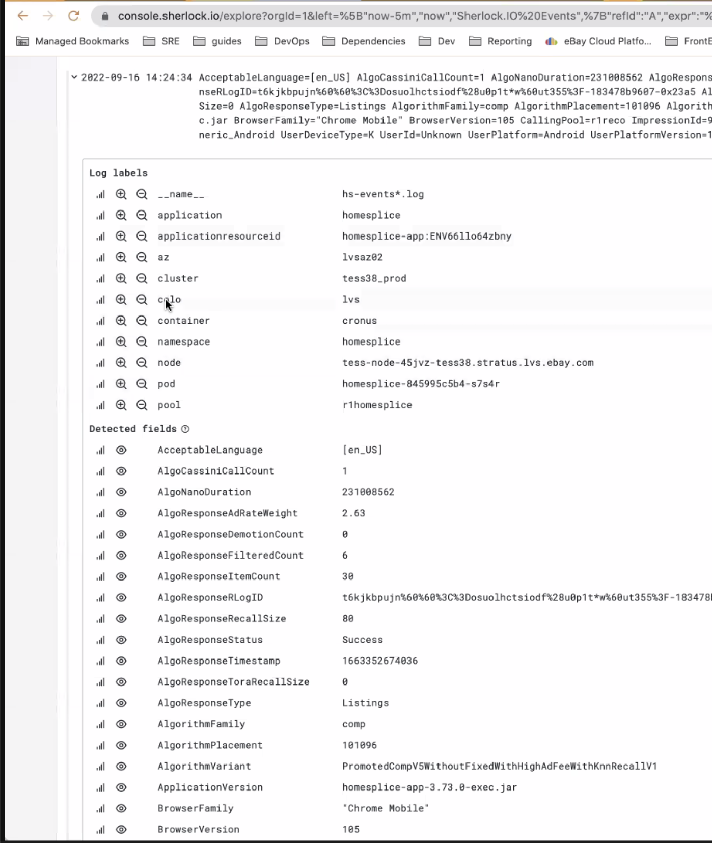

28 days retention



Aggregating on raw data is pretty expensive

Schema = default

* Raw

Schema = all

* Aggregation

What is collapse rate?